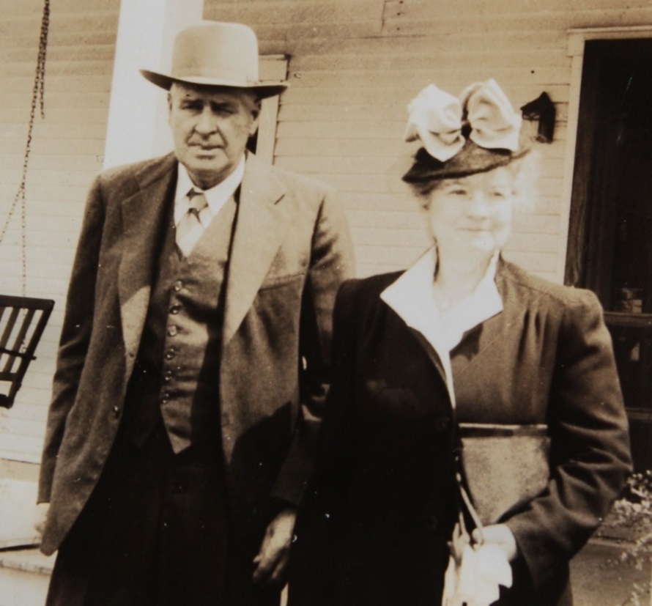

**Earl Russell and Josephine Sybil Worthen Wolfe**

**Easter Sunday – 25 April 1943**



**Earl Russell and Josephine L. Worthen Wolfe – November 1944**